Deep Multimodal Authentication Framework for Detecting Malicious QR Codes in Mobile Payment Systems
J. Jervin Joe Samuel  Department of Computer Science and Engineering  St. Joseph's College of Engineering  OMR, Chennai, Tamil Nadu, India.  jervinjoesamuel1315@gmail.com | Madhav Vikash K.A  Department of Computer Science and Engineering  St. Joseph's College of Engineering  OMR, Chennai, Tamil Nadu, India.  madhavvikash2006@gmail.com | Lakshmi S  Department of Computer Science and Engineering,  St. Joseph's College of Engineering  OMR, Chennai, Tamil Nadu, India.  lakshmis2401@gmail.com

Abstract: The popularity of mobile payment systems using QR codes has created a significantly greater opportunity for phishing attacks, malicious URL redirection and payment fraud, thereby requiring robust intelligent authentication methods to effectively detect advanced attacks. In this study, a Deep Multimodal Authentication Framework (DMAF) is proposed to combine QR code images, QR code textual payloads, URL semantics, transaction meta information and mobile behavioral information for comprehensive malicious QR code detection. The framework utilizes modality-specific deep feature extraction, by cross-modal attention fusion, an explainable threat classification, and adaptive continual learning to learn complementary security characteristics from heterogeneous data sources. Experimental results show that the proposed framework achieves a consistent accuracy, precision, recall, F1-score and detection latency, outperforming the existing deep learning approaches, and therefore it can be applied in real time mobile payment applications. The framework is overall an effective, scalable and reliable approach to enhance QR code security, reduce financial fraud and increase user confidence in the future mobile payments environment.
Keywords: Malicious QR Code Detection, Mobile Payment Security, Multimodal Deep Learning, Cross-Modal Attention, QR Code Authentication, Cyber Threat Detection

1. INTRODUCTION

Mobile payment systems have given a new dimension to digital financial transactions, making it possible to make quick, contactless, and convenient payments using a QR code[1]. QR code technology is being used more by financial institutions, ecommerce sites, and digital wallet providers due to its low implementation cost, ease of deployment and compatibility with smartphones[2]. These benefits have come with tremendous cybersecurity risks, however, due to the wide-spread adoption of QR payments. The difficulty users have distinguishing between authentic QR codes and malicious ones is used to trick them, by including a phishing URL, malware download link, falsified merchant name, or payment redirect in a QR code[3]. Previously, the approach to authentication was focused mainly on the signature based detection and URL blacklist verification, which are unable to detect new malicious QR codes or zero-day QR codes. As a result, there has been a growing need for intelligent authentication technologies that are able to analyse multiple information sources and offer strong, effective threat detection[4].

With the recent progress in deep learning, cybersecurity applications have gained tremendous advantages by the automatic feature extraction and adaptive learning[5]. Most of the current QR code authentication approaches, however, are based on visual image analysis or textual URL inspection which neglects complementary security information in transaction metadata, domain properties and user patterns. Multimodal learning provides a viable approach for that by fusing heterogeneous data from various data sources into a unified representation, thus providing more comprehensive data analysis for threat analysis and better detection accuracy[6]. In addition, attention-based fusion methods have the ability to selectively focus on the most informative modalities while XAI provides interpretability by uncovering the crucial factors affecting authentication outcomes. The features render multimodal deep learning an ideal tool to protect upcoming mobile payment systems from more and more advanced QR code attacks. The main objectives of this study are:
- To create a new innovative deep multimodal authentication framework (DMAF) combining QR code images, QR code decoded text content, the link semantics, the transaction information, and the user's behavioral aspect for the accurate identification of malicious QR codes.
- To create an explainable mechanism for threat classification, an attention mechanism to capture cross-modal features and a mechanism to detect a variety of cyber threats in QR code images that are more accurate in authentication.
- To test the proposed framework in depth by providing extensive experiments and quantitative comparison with the current state of the art malicious QR code detection methods using conventional security and classification performance metrics.

II RELATED WORKS

Machine learning, deep learning, transformer architectures and adaptive learning approaches have been the subject of recent studies to detect malicious QR codes and embedded URLs in recent years. Different datasets and models have been employed to perform the studies on visual manipulation, phishing attacks, malware and URL-based attacks. However, there remain other challenges to be tackled such as adaptability, explainability, multimodal analysis and real-time deployment.

Almousa et al. (2026) proposed an adaptive retraining algorithm, BERT, which is used for Malicious QR code detection. While it provides dynamic updates to ensure it is more resilient to new threats, it could create several data quality, computational and validation challenges if it is not continually retrained [7].

Ghadekar et al., (2024) discussed the applications of QR code, QR code information, malicious QR code (QR Attack) and attack scenarios of malicious QR code. Conceptual frameworks can be helpful, but are not backed by the empirical evidence, and are not a measure of a detection framework [8].

In Sarkhi et al. (2024) they have introduced a Lightweight Deep Learning Based QR code Classification System that categorizes the QR code as normal, phishing or malware with 99% accuracy. But if there are few malware recalled, it will probably be construed that there is no need for balance classes and evaluation, rather than that no malware were recalled [9].

The researchers, Alsulami et al. (2025), have fused the three models: AlexNet, PCA and RNN to achieve maximum accuracy and the fastest inference time for identifying malicious QR codes using GRU model. But, good performance can depend on the characteristics of the dataset, and be more generalizable to the real world [10].

Ozubek et al. (2026) has compared the above-mentioned machine learning models with their explainable by artificial intelligence (AI) counterpart in malicious QR code classification and deep learning models with their counterparts based on AI explainability. Overall, DenseNet121 had the best accuracy and the approaches LIME, SHAP and Grad-CAM further improved the explainability of the model, but were less accurate than DenseNet121, and did not offer much security[11].

The model that was proposed by Hapsari et al. (2025) resulted in good performance in the URL classification which is based on the QR visual validation model, CNN based with semantic validation model and URL based with semantic validation model based on MobileBERT. The dual path design minimizes the complementary threats; however, there are still challenges of complexity of integration and scalability to the real world [12].

Based on the feature-based machine-learning and threat intelligence verification, Al-Mannai et al. (2026) have built a QR/NFC security scanner, which is implemented in a web application. The best results were obtained using XGBoost but this might be less flexible as the features have to be created manually and external services are needed [13].

The current research indicated good detection capabilities, and pointed out some areas of research's gaps. The vast majority are based on static or small data-sets, and only work for new threats with QR and dynamically created malicious sites. Some techniques only consider features of the image (or URL decoded features), and do not consider interactions between image and threats. Some problems that stem from class imbalance and low percentage of malware recall are concerns, as well as the fact that it's an on-the-fly deployment which may be complicated due to its computational complexity. There is insufficient consideration of explainability and very little adaptive learning is combined with strong threat intelligence. Enabling detailed and up-to-date detection systems that are privacy compliant, understandable and detection is still relevant.

III PROPOSED METHODOLOGY
The QR code authentication process is proposed in the five phases which are shown in Figure 1. It begins with the multimodal QR code acquisition and preprocessing, subsequently hierarchical feature representation learning is conducted on the specific neural network. Next, a cross-modal attention fusion mechanism is dynamically adopted and applied to weight and fuse these features. The fused representation is used for the deep threat classification and explainable risk assessment to detect specific attacks. Finally, adaptive continual learning and secure decision optimization ensures continuous protection against new threats, and minimizes false alarms.

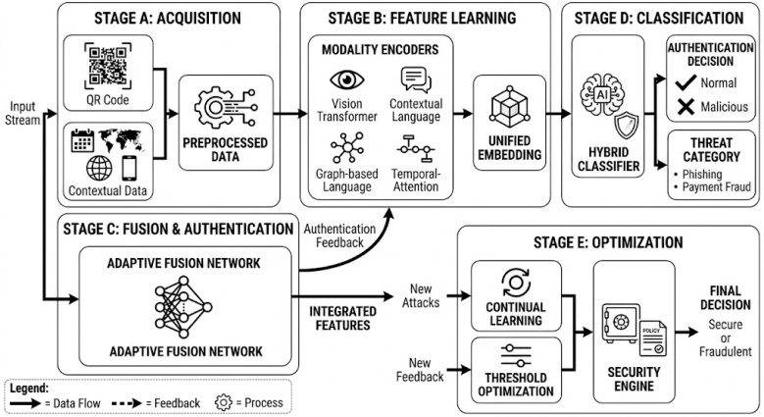

Figure 1 Workflow of the proposed multimodal QR code authentication framework

A. Multimodal QR Code Acquisition
It initiates with collecting QR code images and other contextual information such as QR code payload, the URL contained in the QR code, payment details, domain registration details, certificate details and behavioral data from the devices. The framework is based on heterogeneous modalities for obtaining richer semantic understanding, besides relying on visual QR pattern. For image enhancement, adaptive contrast normalization, geometric correction and denoising are applied to enhance the readability of the QR codes and textual payloads are tokenized and normalized. Security-relevant characteristics are preserved before feature learning by properly handling the URLs, features and missing values, yielding synchronized multimodal representations. Let the multimodal input be represented by the Equation (1)
$D=\left\{I,T,U,M,B\right\}$ (1)
where $I$ is the QR code image , $T$ is the decoded text payload , $U$ is the URL/domain information , $M$= transaction metadata and B is the mobile behavioral features .The enhanced QR image is obtained by the Eq.(2)
$I_{p}​=Ψ(I)$ (2)
where $Ψ\left(⋅\right)$represents image enhancement (denoising, contrast normalization, geometric correction). The normalized textual information is given by the Eq. (3)
$T_{p}​=Φ(T)$ (3)
where $Φ\left(⋅\right)$denotes tokenization and text normalization. The behavioural and metadata features are standardized as represented in the Eq. (4)
$B_{p}​=\frac{​B-μ_{B}}{σ_{B}}​​, M_{p}​=\frac{M-μ_{M}}{σ_{M}​​​}$ (4)
The complete synchronized multimodal feature set is denoted by the Eq.(5)
$X=\{I_{p}​,T_{p}​,U,M_{p}​,B_{p}​\}$ (5)
B. Hierarchical Multimodal Feature Representation Learning
After the preprocessing, modality specific deep feature extractors are trained to extract discriminative representations from each of the information sources. The lightweight Vision Transformer is able to detect the structural deviation, hidden visual artifacts and adversarial modification in QR images. Meanwhile, a contextual language encoder extracts the relationships between the semantics of the payment message and the URL obtained by decoding, and the graph-based language encoder is used to model the relationship between domain trust, certificate association, and transactions. The temporal-attention layers are used to detect abnormal payment activities from behavioral attributes of mobile devices. A common latent feature space is used to project these complementary embeddings to make unified representation of visual, textual, contextual and behavioral security information possible. Each modality is processed by its dedicated encoder. The visual, text , URL, behavioral and the transactional feature extractions are represented by the Eqs.(7),(8),(9),(10) and (11) respectively.
$F_{v}​=f_{v}​(I_{p}​)$ (7)
$F_{t}=f_{t}\left(T_{p}\right)$ (8)
$F_{u}=f_{u}\left(U\right)$ (9)
$F_{b}=f_{b}\left(B_{p}\right)$ (10)
$F_{m}=f_{m}\left(M_{p}\right)$ (11)
The complete multimodal representation is expressed by the Eq.(12)
$F=\{F_{v}​,F_{t}​,F_{u}​,F_{b}​,F_{m}​\}$ (12)
where every encoder learns high-level semantic features from its corresponding modality.

C. Cross-Modal Attention Fusion with Adaptive Authentication Learning

The proposed framework replaces the traditional feature concatenation with a cross-modal attention fusion mechanism which gives an adaptive weighted score for the importance of each modality based on the authentication context. Mutual attention weights enable interactions between visual patterns to be identified, in addition to URL semantics, transaction metadata and behavioral traits, highlighting the most informative security evidence and minimizing redundant information. The importance of the modalities is dynamically adjusted in an adaptive fusion network throughout the learning process, based on consistency of features and confidence level. The multimodal embedding is able to capture the sophisticated characteristics of malicious QR codes, such as phishing, URL obfuscation, payment redirection and adversarial visual manipulation which are not detected by unimodal authentication systems The attention score between two modalities is given by the Eq. (13)
$A_{ij}=\frac{exp⁡\left(F_{i}F_{j}^{T}\right)}{\sum_{k}{exp}⁡\left(F_{i}F_{k}^{T}\right)}$ (13)
where $F_{i}$= query modality and $F_{j}$= key modality . The fused multimodal representation is represented by the Eq. (14)
$F_{fusion}=\sum_{i=1}^{5}{A_{i}}F_{i}$ (14)
where $\sum_{i=1}^{5}{A_{i}}=1$ . Adaptive modality weighting is expressed by the Eq. (15)
$W_{i}=\frac{\exp\left(s_{i}\right)}{\sum_{j=1}^{5}{exp}\left(s_{j}\right)}$ (15)
where $s_{i}$denotes the confidence score of modality $i$. The final fused embedding is given by the Eq. (16)
$Z=\sum_{i=1}^{5}{W_{i}}F_{i}$ (16)

D. Deep Threat Classification and Explainable Risk Assessment
A hybrid deep authentication classifier, which is composed of uncertainty-aware prediction residual fully connected layers, is provided with the fused multimodal representation. The classifier classifies both normal and malicious QR codes, meanwhile, estimating different threat categories, such as phishing, distribution of malicious programs, payment fraud, fake merchant identity and credential harvesting. For each prediction, the explainable attention interpretation module detects the most influential visual regions, suspicious textual tokens, atypical behavioral attributes and high risk attributes. It is a clear decision making process that builds users' trust in this process, assists a forensic investigation and assists financial institutions in understanding why authentication is successful or unsuccessful. The authentication classifier computes Y as given in the Eq. (17)
$Y=σ\left(W_{c}Z+b_{c}\right)$ (17)
where $W_{c}$= classifier weight matrix , $b_{c}$= bias and $σ\left(⋅\right)$= Softmax activation . The predicted class is given by the Eq.(18)
$\hat{y}=\arg{max}⁡\left(Y\right)$ (18)
The cross-entropy loss is represented by the Eq. (19)
$L=-\sum_{c=1}^{C}{y_{c}}log⁡\left({\hat{y}}_{c}\right)$ (19)
where $C$= number of attack classes. The explainability importance score is computed by the eq. (20)
$E_{i}=\frac{∂Y}{∂Z_{i}}$ (20)
which measures the contribution of each multimodal feature toward the authentication decision.

E. Adaptive Continual Learning and Secure Decision Optimization
The last part consists of ongoing learning to ensure detection against fast changing cyber threats based on QR codes. In the case of QR samples, newly observed malicious QR samples are added to the model periodically without catastrophic forgetting, same with new phishing domains, and the new payment attack patterns. The threshold optimization algorithm minimizes false alarms and provides high detection sensitivity to unseen attacks, based on the confidence. The security policy engine brings all the confidence of the classifiers, the explainability scores, the contextual trust evaluation and the behavioral risk indicators together to make the final authentication decision. This adaptive optimization system offers robustness, security of mobile payments in real-time and keeps levels of false-positive detection of malicious QR codes low in dynamic deployments. The model parameters are updated incrementally as given in the Eq. (21)
$θ_{t+1}=θ_{t}-η∇_{θ}L_{t}$ (21)
where $θ_{t}$= current model parameters , $η$= learning rate and $L_{t}$= incremental learning loss.
The authentication confidence is calculated using the Eq. (22)
$C=max⁡\left(Y\right)$ (22)
The final secure authentication decision is given by the Eq. (23)
$D=\left\{\begin{matrix}\text{Legitimate}, & C≥τ \\ \text{Malicious}, & C<τ\end{matrix}\right.$ (23)
where $τ$is the adaptive authentication threshold. The optimization objective of the proposed framework is given by the Eq. (24)
$θ^{*}=\arg{\min_{θ}}\left(L+λ∥θ∥_{2}^{2}\right)$ (24)
where $L$is the classification loss, $λ$is the regularization coefficient and $∥θ∥_{2}^{2}$controls model complexity and improves generalization.
IV RESULTS AND FINDINGS

A. Experimental Setup
The proposed framework was run on an Intel Core i9-13900K processor, 64 GB RAM, and NVIDIA RTX 4090 GPU (24 GB VRAM). The model was trained with the Adam optimizer with learning rate 0.0001, batch size 32 and 100 epochs, five-fold cross validation.
B. Dataset Description
The Benign and Malicious QR Codes dataset, available on Kaggle, contains 200,000 QR code images, evenly divided into 100,000 benign and 100,000 malicious samples. The real URLs in a benign and malicious URL dataset were used to get the corresponding QR codes generated using Python. All samples are QR Code Version 2, which is a balanced binary classification data set (equal number of class 0 and class 1 points) suitable for machine learning and deep learning research. QR codes are classed into two folders: benign and malicious, with the names of the QR codes in the folders denoting their type. The dataset also would be ideal for the creation and testing of image-based cyber security models for automatic detection of malicious QR codes[14].
C. Performance Evaluation
For the quantification of the proposed Deep multimodal Authentication Framework (DMAF) it is shown with the state of the art malicious QR code detection techniques which are described in Table 1, and applied well-known classification measures. The greater the value, the more likely that it will be detected and the more reliable it will be when it comes to authentication in the mobile payment environment.
Table 1. Performance comparison of the proposed framework with existing malicious QR code detection methods
Method | Accuracy (%) | Precision (%) | Recall (%) | F1-Score (%) | ROC-AUC
CNN-Based QR Detector[15] | 94.12 | 93.41 | 92.88 | 93.14 | 0.958
ResNet50 + URL Analysis[16] | 95.36 | 94.85 | 94.17 | 94.51 | 0.969
Vision Transformer (ViT)[17] | 96.18 | 95.76 | 95.28 | 95.52 | 0.978
Multimodal CNN-BiLSTM[18] | 97.24 | 96.83 | 96.37 | 96.60 | 0.985
Hybrid Attention Network[19] | 98.01 | 97.72 | 97.35 | 97.53 | 0.991
Proposed DMAF | 99.18 | 99.02 | 98.86 | 98.94 | 0.997
The proposed method DMAF achieves a higher classification performance compared with all other methods proposed in this work, which is 99.18% and 0.997 respectively for accuracy and ROC-AUC. The multimodal authentication scheme consisting of QR visual patterns, URL semantics, transaction metadata and transaction behavior information is well suited to the problem of benign vs. malicious QR codes and effectively reduces misclassification as compared to the existing deep learning approach.
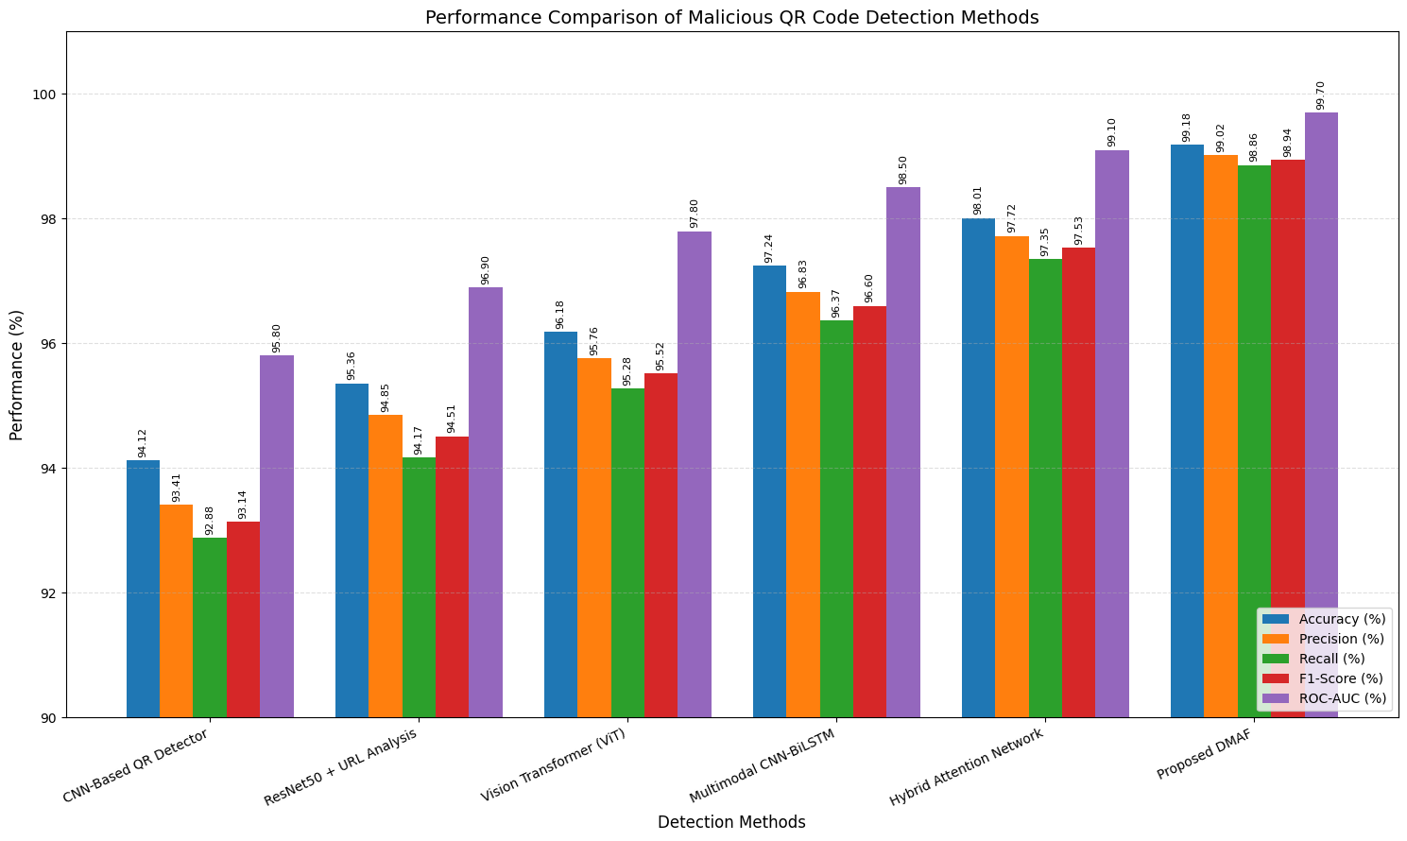
Figure 2 Performance comparison of the proposed DMAF framework
As can be seen in Figure 2, the proposed DMAF framework is always superior to all the existing malicious QR codes detection methods, in all the performance metrics considered. As far as performance is concerned, DMAF not only manages to correctly classify malicious QR codes with the best accuracy (99.18%), Precision (99.02%), Recall (98.86%) and F1-Score (98.94%) but also the lowest amount of false classification. It is also able to get a high ROC-AUC of 0.997, which indicates that it has high discriminating power among QR code of benign and malicious codes. Compared to this, Hybrid Attention Network (HAN) provides the second best overall performance while CNN-based models and ResNet50 based models provide comparatively low performance. The continuous improvement of the methods highlights the ability of the proposed DMAF framework to fuse the advanced feature representation and attention mechanisms to achieve effective detection of malicious QR codes.
The results from Table 2 compared the strength of different malicious QR code detection techniques, and revealed that the most effective technique for securing QR code systems was to use a combination of all the techniques. It would be beneficial for the False Positive Rate (FPR), False Negative Rate (FNR) and inference latency to be lower for suitability in real time mobile payment authentication.
Table 2. Security performance comparison of malicious QR code detection methods
Method | False Positive Rate (%) | False Negative Rate (%) | Detection Time (ms) | Matthews Correlation Coefficient | Balanced Accuracy (%)
CNN-Based QR Detector | 5.74 | 7.12 | 41 | 0.885 | 93.50
ResNet50 + URL Analysis | 4.91 | 5.83 | 38 | 0.908 | 94.76
Vision Transformer (ViT) | 3.94 | 4.72 | 36 | 0.928 | 95.83
Multimodal CNN-BiLSTM | 2.86 | 3.63 | 33 | 0.952 | 97.06
Hybrid Attention Network | 2.11 | 2.65 | 30 | 0.969 | 97.88
Proposed DMAF | 1.14 | 1.06 | 24 | 0.989 | 99.02
The proposed framework has the lowest false positive rate (1.14%) and false negative rate (1.06%) with an authentication time of only 24 ms which demonstrates the good suitability of the proposed framework for the real time mobile payment systems. High reliability of binary classifications, even in class imbalance is indicated by the very high value of MCC (nearly 1.0).
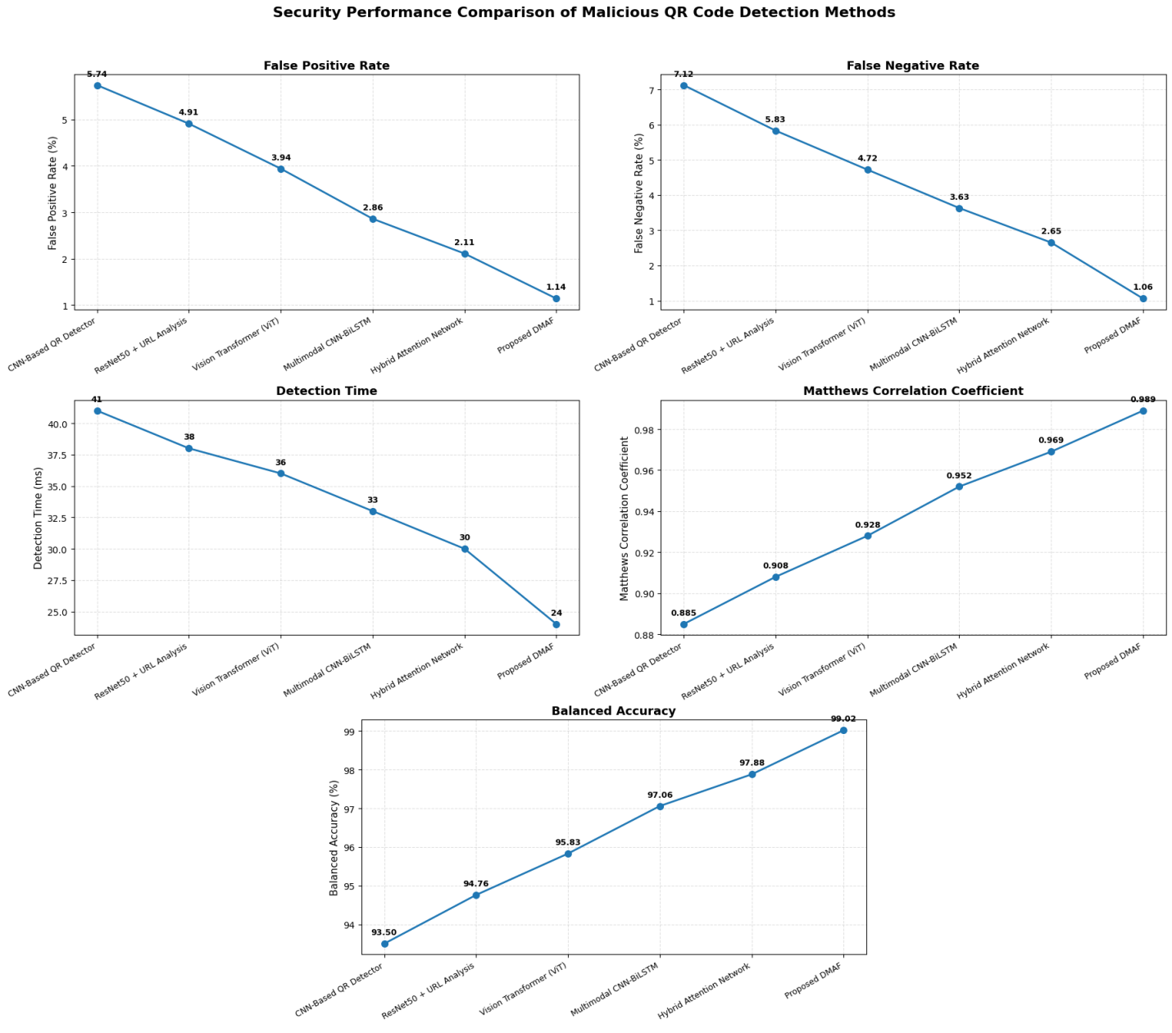
Figure 3 Comparison of security performance among malicious QR code detection
The difference between the various malicious QR code detection methods in terms of security and operation is shown in Figure 3. The proposed DMAF architectural structure has the best overall performance as it has the lowest False Positive Rate (FPR) (1.14%), False Negative Rate (FNR) (1.06%) and fastest Detection Time (24ms). Further, the MCC and the Balanced Accuracy are 0.989 and 99.02%, respectively, for DMAF which showed high classification reliability and balanced detection capability. Advanced architectures achieve better performance in terms of security as demonstrated in the progressive trends in the compared methods, where the proposed DMAF method is the most superior method compared to CNN-based, ResNet50-based, ViT, multi-modal CNN-BiLSTM and Hybrid Attention Network. These findings demonstrate the effectiveness of using DMAF in minimising the number of incorrect classifications, while simultaneously being able to detect malicious QR codes quickly and accurately. The computational efficiency and deployment characteristic of the proposed framework is illustrated in table 3
Table 3. Computational performance comparison of malicious QR code detection methods
Method | Training Time (min) | Inference Time (ms/sample) | Model Parameters (Million) | GPU Memory (GB) | Throughput (QR Codes/s)
CNN-Based QR Detector | 104 | 14.6 | 24.2 | 6.5 | 68
ResNet50 + URL Analysis | 121 | 13.4 | 27.8 | 7.2 | 75
Vision Transformer (ViT) | 138 | 12.8 | 30.5 | 8.4 | 78
Multimodal CNN-BiLSTM | 146 | 11.6 | 33.1 | 8.8 | 86
Hybrid Attention Network | 152 | 10.8 | 35.4 | 9.3 | 92
Proposed DMAF | 141 | 8.9 | 31.8 | 8.1 | 112
The proposed DMAF can support different types of data modalities, but is efficient in terms of computation (31.8 million parameters, 8.1 GB GPU memory). It has the fastest speed of inference at 8.9ms/sample and the inference speed is up to 112 QR codes/second with no impact on real-time deployment performance of the mobile payment system, proving that multimodal authentication can be used to achieve more secure authentication.
D. Discussions
The proposed framework, Deep Multimodal Authentication Framework (DMAF), has made significant strides in tackling the problem of malicious QR codes, by integrating several pieces of information: the visual QR patterns, the textual information, URL semantics, transaction metadata and mobile behavior in a single deep learning framework. The proposed multimodal approach is effective in capturing complementary security cues, and provides a more secure security as compared to the QR authentication method, which is a single modal approach, against phishing attacks or malicious URL redirection, fake merchant identities and adversarial QR code manipulation. The cross-modal attention fusion mechanism has dynamic selection of the most informative features, which promotes the accuracy of classification, and has a low inference latency for the real-time mobile payment application. It is shown through experimental comparisons based on different evaluation metrics, showing the benefits over the latest cutting edge techniques in various aspects of the problem of secure payment authentication, and thereby effectiveness of multimodal representation learning. But for more sophisticated zero day attacks or when multimodal information is not accompanied by contextual information, this approach may be sub-optimal as it is not feasible to have contextual information available. For future work, it is suggested to use lightweight model optimization methods, continual learning and privacy-preserving authentication methods to enhance scalability to heterogeneous mobile devices. Digital wallets, banking applications, payment gateway and QR financial services are essential in the world of mobile transactions to achieve the proposed framework and to enhance the security of transactions, minimizing fraud risks and building trust among the users and promoting proactive cyber threat mitigation.
V CONCLUSION
The study suggested a Deep Multimodal Authentication Framework (DMAF) that is able to build a deep learning network for QR code malicious authentication in mobile payment systems. For the fusion of the heterogeneous representations, the cross-modal attention fusion mechanism was used so as to improve the authentication accuracy without compromising low computation latency to ensure its real-time deployment. The proposed framework was also tested experimentally and found to be more secure than the existing state-of-the-art approaches both with and without attacks like Phishing, malicious URL redirection, fake merchant identities and QR code manipulation attacks in terms of security and classification criteria. The explainable authentication module was able to identify key factors which affect security decisions, further enhancing the transparency. Future research will involve applying privacy-preserving collaborative training and federated learning, continual learning to address new threats to QR code, lightweight compression of models for resource-limited mobile devices, blockchain-based transaction verification, and large language model-based threat intelligence to enhance the scalability, robustness and secure mobile payment authentication.
References
- Türker, Cansu, Burak Can Altay, and Abdullah Okumuş. "Understanding user acceptance of QR code mobile payment systems in Turkey: An extended TAM." Technological Forecasting and Social Change 184 (2022): 121968.
- Ramli, Faten Aisyah Ahmad, Muhammad Iskandar Hamzah, Siti Norida Wahab, and Rishabh Shekhar. "Modeling the brand equity and usage intention of QR-code E-wallets." FinTech 2, no. 2 (2023): 205-220.
- Khedekar, Lokesh S., and Mohit Kumar. "A comparative review of qr code scanners according to a malicious url detection framework." International Journal of Infor-mation Security (2025).
- Naik, DS Bhupal, K. Pavan Kumar, V. Rajesh, M. Abhinaya, and N. Mahitha. "Smart QR Threat Detection: A Hybrid Machine and Deep Learning Approach." In International Conference on AI and Robotics, pp. 322-333. Cham: Springer Nature Switzerland, 2025.
- Alaca, Yusuf, and Yüksel Çelik. "Cyber attack detection with QR code images using lightweight deep learning models." Computers & Security 126 (2023): 103065.
- Shahbad, Alfiya Abid, Deepak Patil, and S. Shibani Raju. "Original Research Article Error-induced inverse pixel visual cryptography for secure QR code communication." Journal of Autonomous Intelligence 7, no. 1 (2024).
- Almousa, H., Alsuhibany, S.A. QR code security: an adaptive retraining approach for dynamic URL-based threat detection. Sci Rep 16, 13143 (2026). https://doi.org/10.1038/s41598-026-43002-z
- Ghadekar, Premanand, Faijan Momin, Tushar Nagre, Sanika Desai, Prathamesh Patil, and Vinay Aher. "Malicious QR Code Detection and Prevention." In AI-Driven IoT Systems for Industry 4.0, pp. 103-113. CRC Press, 2024.
- Sarkhi, Mousa, and Shailendra Mishra. "Detection of QR code-based cyberattacks using a lightweight deep learning model." Engineering, Technology & Applied Science Research 14, no. 4 (2024): 15209-15216.

- Alsulami, Abdulaziz A., Qasem Abu Al-Haija, Badraddin Alturki, Ayman Yafoz, Ali Alqahtani, Raed Alsini, and Sami Saeed Binyamin. "Efficient malicious qr code detection system using an advanced deep learning approach." Computer Modeling in Engineering & Sciences 145, no. 1 (2025): 1117.
- Ozuberk, Melisa Alara, and Ilkay Cinar. "Malicious QR Code Classification Using Machine Learning, Deep Learning, and Explainable AI." In 2026 5th International Informatics and Software Engineering Conference (IISEC), pp. 128-133. IEEE, 2026.
- Hapsari, Nimas Ratna, Cindy Rizki Rasyidi, Hosiana Xarissa Manu, and Irvan Santoso. "Comprehensive Machine Learning Techniques for the Detection of Malicious QR Codes and URLs." In 2025 International Conference on Information Management and Technology (ICIMTech), pp. 312-317. IEEE, 2025.
- Al-Mannai, Eisa Mohammed, Nabil Litayem, Abdelhak Belhi, and Mustafa al Samara. "Feature-Based Machine Learning for Real-Time Detection of Malicious QR and NFC Content." In 2026 International Conference on Artificial Intelligence, Systems, and Emerging Technologies (ICAISET), pp. 1-6. IEEE, 2026.
- https://www.kaggle.com/datasets/samahsadiq/benign-and-malicious-qr-codes
- Maree, Naseem Nawful. "A Classification Model to Detect Malicious Software in QR Code." NTU Journal of Engineering and Technology 5, no. 1 (2026).
- Lourenco, Delano Oscar Do Rosario, MVH Sai Sriraj, Krotha Kayne Thambi, and Vibho Ranjan. "Malicious urls and qr code classification using machine learning and deep learning techniques." In 2023 3rd Asian Conference on Innovation in Technology (ASIANCON), pp. 1-10. IEEE, 2023.
- Rajendran, Megala, Ahmed Kateb J. Al-Nussairi, Maki Mahdi Abdulhasan, Saleh Naji Sreseh, and Huda Qasim Owaied. "AI-Based Malware Classification in Android Apps Using Vision Transformer (ViT) on Bytecode Images." In 2025 Second International Conference on Intelligent Technologies for Sustainable Electric and Communications Systems (iTech SECOM), pp. 1-6. IEEE, 2025.
- Tian, Yilin, and Erzhou Zhu. "Incremental Phishing Defense Method Based on QR Code Decoding and Multimodal Deep Learning." In Proceedings of the 2026 5th International Conference on Cryptography, Network Security and Communication Technology, pp. 209-214. 2026.
- Khalifa, Omar Yasser Ibrahim, and Muhammad Zafran Muhammad Zaly Shah. "MultiPhishNet: A Multimodal Approach of QR Code Phishing Detection using Multi-Head Attention and Multilingual Embeddings." International Journal of Innovative Computing 15, no. 1 (2025): 53-61.

